|  |
| --- |
| 2019/20 |
| Softwarica College of IT & E-Commerce / Coventry University |
| **Course Name** |
| Module Code: STW210CT |
| Module Name: Programming, Algorithms and Data Structures |
| Instructions to candidates |
| Time allowed:2 Hours 0 minutes |
| Answer: All Questions Full Marks: 100  Pass Marks: 40  The total number of questions in this paper: 4  Start each question **on a new page** and carefully identify your answers with the correct question number |
| For this examination you will be supplied with the following:  1 Answer Book/s |
|  |
| You must hand this question paper in at the end of the examination. |

**Question 1** Total for Question 1: 25 Marks

1. Write a program to insert node at the beginning of Singly Linked List.

(10 marks)

b) Write a program to delete last node of Singly Linked List

(10 marks)

1. Specify an algorithm in the language of choice to reverse the digits.

Input: example: 23567

Output: 76532 (5 marks)

|  |  |  |  |
| --- | --- | --- | --- |
| **Question 2** | | Total for Question 2: 25 Marks | |
| a) Write the pseudocode for a function that determines whether an array is a palindrome (reads the same in both directions). Example input: L = [1,3,6,6,3,1] Example output: Yes  Example input: L = [2,5,8,9,1] | | | (10 marks) |
| b) Use pseudocode to describe the quick Sort algorithm. | | | |
| (10 marks) |
|  |
| c) What is the time complexity of binary search. Describe with example. | | | |
|  | | | (5 marks) |

**Question 3** Total for Question 3: 25 Marks

a) Write complete program in java to create binary tree.

(10 marks)

b) Describe breadth first binary tree traversal. Mention the output of breadth first traversal in the tree given below:

(6 marks)

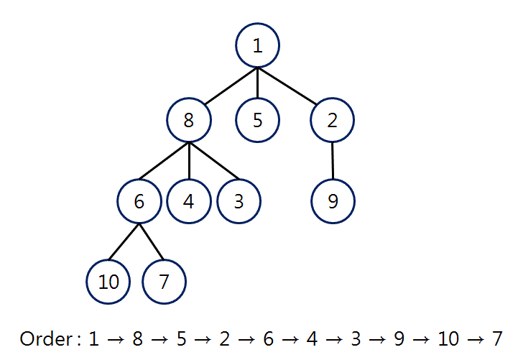

c) What is the out of (In-order, Preorder, Post-order) Traversals of the following Tree.

(9 marks)

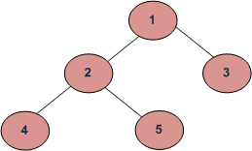

**Question 4** Total for Question 4: 25 Marks

What type of graph is the below given graph? Identify the right option for below given criteria. (5 marks)

|  |  |  |  |  |  |  |
| --- | --- | --- | --- | --- | --- | --- |
| directed | ***or*** | undirected | connected | ***or*** | unconnected |  |
| weighted | ***or*** | unweighted | cyclic | ***or*** | acyclic |  |

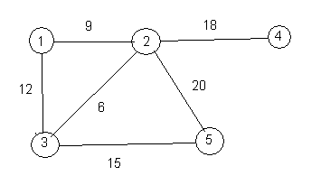

b) Write a complete adjacency matrix and adjacency list representation of Graph given above.

(10 marks)

c) In the graph below, describe along with pseudocode how breadth first search is performed

. (10 marks)

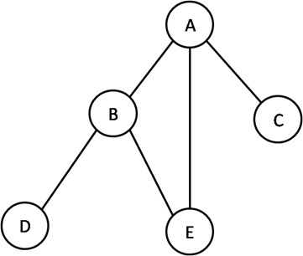

End